**Installation of cPanel with Nginx on AWS EC2 Instance (Alma Linux 8)**

### **Steps to install cPanel and WHM**

1. Create an EC2 Instance

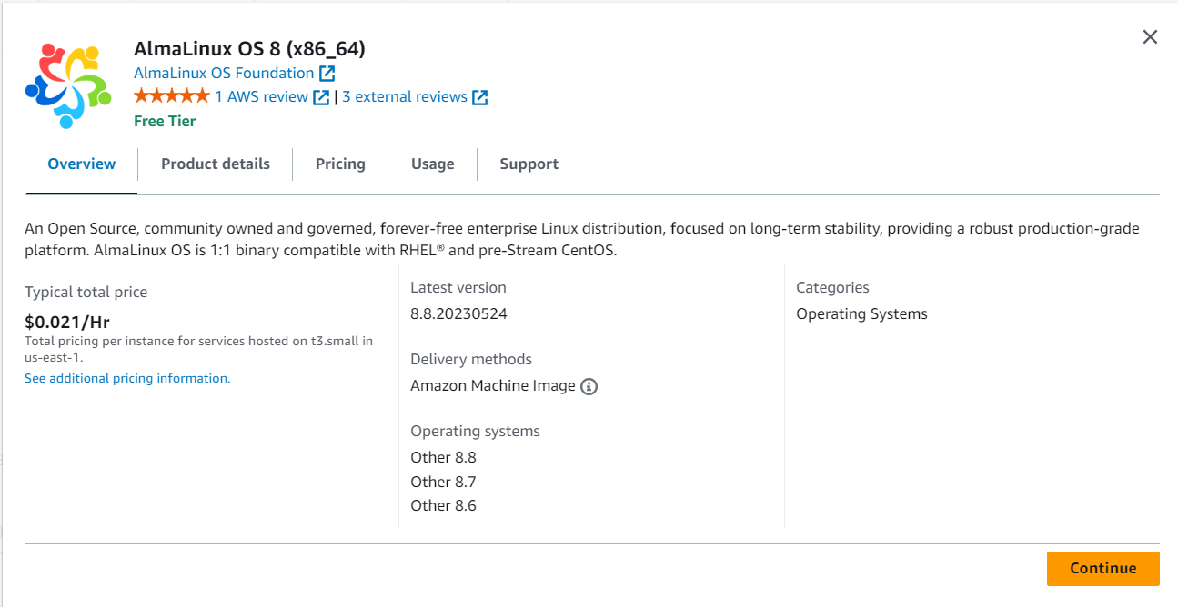

Choose at least t2 micro instance type.

Add 40 GB of Storage to your root volume.

Configure the Security Group by adding rules for these custom ports.

* SSH with source anywhere (You can also restrict it)
* HTTP with source anywhere
* HTTPS with source anywhere
* DNS (UDP) with source anywhere
* DNS (TCP) with source anywhere
* Custom TCP 2077 with source anywhere
* Custom TCP 2078 with source anywhere
* Custom TCP 2082 with source anywhere
* Custom TCP 2083 with source anywhere
* Custom TCP 2086 with source anywhere
* Custom TCP 2087 with source anywhere
* Custom TCP2096 with source anywhere
* Custom TCP 3306 with source anywhere
* Custom TCP 2525 with source anywhere
* Create an instance by creating a new pem key to access your instance using SSH. Keep this key safe,
* without this key you cannot access the instance.

1. Take a Putty session.

1. 3. Download the latest cPanel and install it by running the following command.

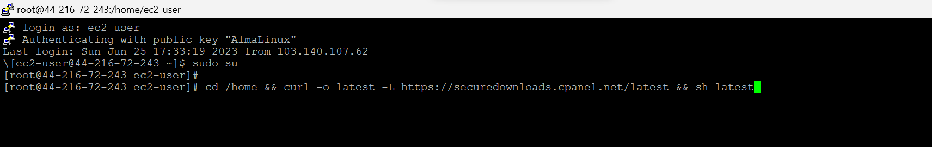

1. It will take around 30 – 40 min to complete the install. Don’t close the terminal until the setup is completed.
2. Once the setup is completed, you can set the root password by executing the following command

1. Save your password safely, you will need that to login to your WHM.

### Setup WHM

Open your browser and navigate In this case, you can use your IP Address instead of the domain name (https://PUBLIC_IP_ADDRESS:2087). It will take some time for the SSL certificate to get issued by cPanel.

1. Enter **username** as root
2. Enter the **password** you created by running the command passwd
3. Now you will be logged into your WHM.Click **Agree to All**. Provide your email address.

* Install Nginx Manager

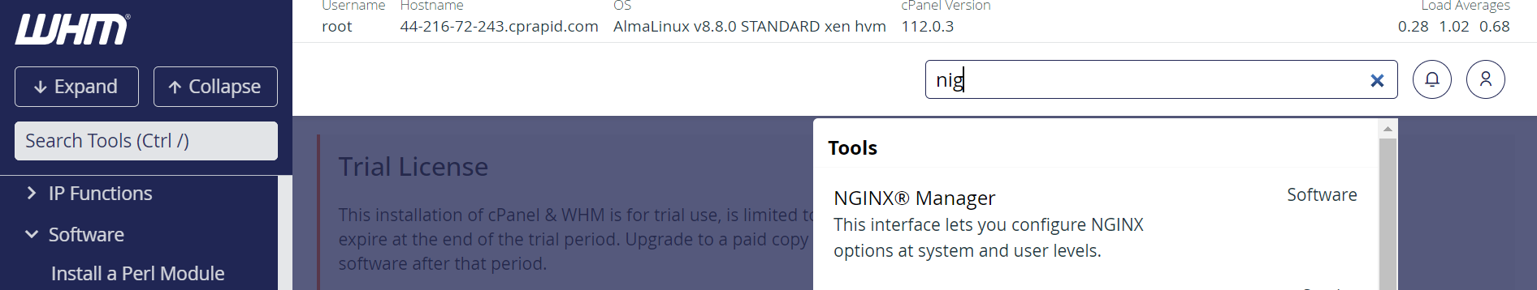

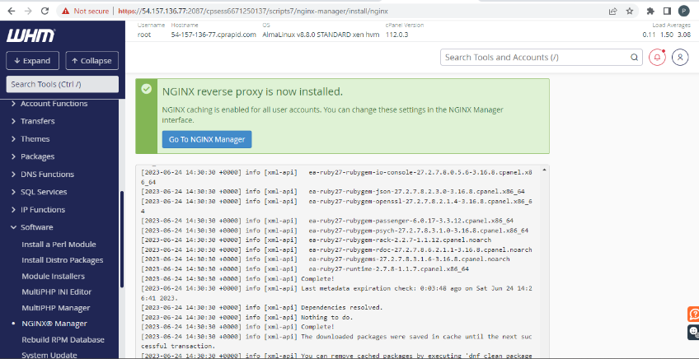

* Go to putty session and enter these commands.

login as: ec2-user

Authenticating with public key "AlmaLinux"

Last login: Sun Jun 25 15:01:31 2023 from 103.140.107.62

[ec2-user@44-216-72-243 ~]$

[ec2-user@44-216-72-243 ~]$

[ec2-user@44-216-72-243 ~]$

[ec2-user@44-216-72-243 ~]$

[ec2-user@44-216-72-243 ~]$ sudo su -

Last login: Sun Jun 25 15:01:35 UTC 2023 on pts/1

[root@44-216-72-243 nginx]# cd /usr/share/nginx

[root@44-216-72-243 nginx]# cd html

[root@44-216-72-243 html]# ll

total 8

-rw-r--r--. 1 root root 497 Jun 13 16:21 50x.html

-rw-r--r-- 1 root root 108 Jun 25 17:38 index.html

[root@44-216-72-243 html]# vi index.html

[root@44-216-72-243 html]#

<!DOCTYPE html>

<html>

<body

<h1>My Website is working on NGINX!</h1>

<p>Hello Earth!!!</p>

</body>

</html>

<!DOCTYPE html>

<html>

<head>

<title>Error</title>

<style>

html { color-scheme: light dark; }

body { width: 35em; margin: 0 auto;

font-family: Tahoma, Verdana, Arial, sans-serif; }

</style>

</head>

<body>

<h1>An error occurred.</h1>

<p>Sorry, the page you are looking for is currently unavailable.<br/>

Please try again later.</p>

<p>If you are the system administrator of this resource then you should check

the error log for details.</p>

<p><em>Faithfully yours, nginx.</em></p>

</body>

</html>

~

Hit Public ip/index.html

